Restore steps for CVM+CMK

Restore to same region as the source VM and original keys/AKV/MHSM used by source VM exists
- Use the script Restore-IaaSVM-CVM-RestAPI.ps1
- Do not provide ‘CVM DES ID’ input in the script

Restore to vault region

Restore to same region as the source VM and when original keys/AKV/MHSM do not exist
- Use the script Restore-IaaSVM-CVM-RestAPI.ps1 to trigger 1st restore, provide ‘CVM DES ID’ input in the script.
  - This DES should be of Encryption type - “Confidential disk encryption with CMK”
  - This DES can point to any key (does not matter for the 1st restore)
- The first restore is expected to fail, but the backup key materials have been restored to the storage account used during restore. The restore can fail with different error codes, like – UserErrorKeyVaultPermissionsNotConfiguredForCVMWithCMK, UserErrorInputDESKeyDoesNotMatchWithOriginalKey
- Go to the Recovery Services vault portal, look for the restore job corresponding to this VM.
- In the restore job, you can get the details where the backup key material has been restored, “Target Storage Account Name”, “Config Blob Container Name”, “Secured Encryption Info Blob Name”
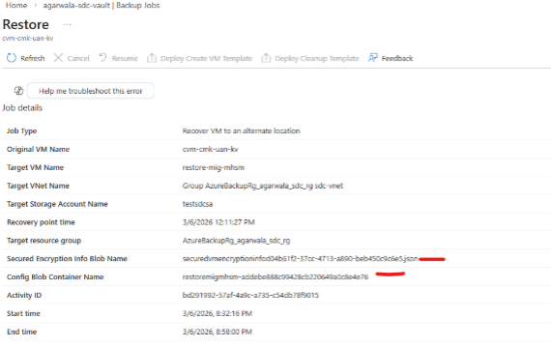
- Prepare a MHSM or AKV in the target restore location for restoring keys. Target location MHSM must be in same security domain as MHSM in source CVM location. In case of AKV, it must be in the same subscription and geographical boundary as the AKV used by the source CVM.
- Use this script Restore-CvmEncryptionKey.ps1 to restore the key in target MHSM/AKV.
- Create a new DES of encryption type "Confidential disk encryption with a customer managed key" pointing to the restored key in step #6.
- Ensure following permissions are set
  - MHSM permissions via Local RBAC
    - Newly created DES must be assigned Managed HSM Crypto Service Encryption User Role
    - ‘Backup Management Service’ must be assigned Managed HSM Crypto User Role
    - ‘Confidential VM Orchestrator’ must be assigned Managed HSM Crypto Service Release User role.
  - AKV permission via Access Policies
    - Newly created DES must be assigned Get, Wrap Key, Unwrap Key, List on Keys
    - ‘Backup Management Service’ must be assigned Get, List, Backup on Keys and Secret
    - ‘Confidential VM Orchestrator’ must be assigned Get, Release permission on Keys

- Trigger 2nd restore using the script Restore-IaaSVM-CVM-RestAPI.ps1, and pass DES ID from step #7 in ‘CVM DES ID’

